=== Scanner 3 Bold Screen Set up ===

1. First locate the Bold Screen Power Box in the scanning room and turn it on.
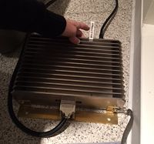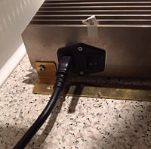

2. Logon to whichever computer you would like to use for the bold screen. You are able to use the Mac or windows computer in the console room or you can use your own laptop. If using your laptop just make sure that you plug your laptop into the laptop computer hookup.
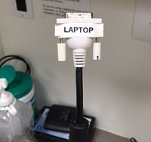

3. Find the computer selector strip and click the button to select what computer you are using.
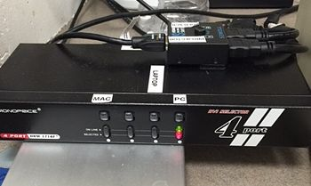

4. You should see a mirrored image of whichever computer you are using on the Bold screen. You are all set once it is mirrored onto the screen. (sometimes you may have to toggle the computer selector button a couple times if it is not showing up)
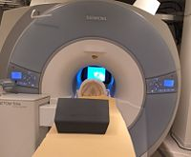

5. After Scanning Please don't forget to go back into scanning room to TURN OFF the bold screen by flipping the switch on the Bold Screen Power Box and Log off of the computer.

