=== Scanner 5 Bold Screen Setup===
1. First locate the Bold Screen Power Strip and turn it on. (This will turn on the monitors in the console room as well as the Boldscreen in the scanner.
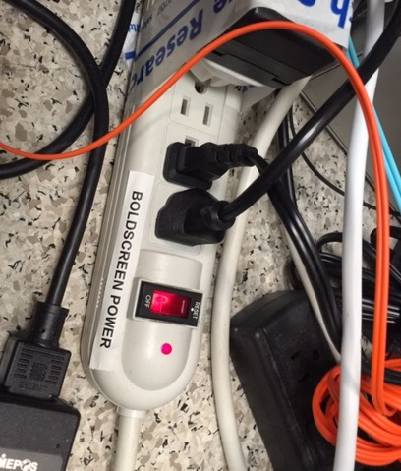

2. Logon to whichever computer you would like to use for the bold screen. You are able to use the Mac or windows computer in the console room or you can use your own laptop. If using your laptop just make sure that you plug your laptop into the laptop computer hookup pictured below (must plug in both cords).
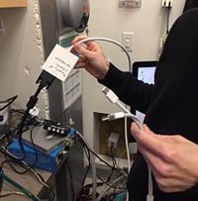

3. Find the computer selector strip and click the little black button on the front right of box to select what computer you are using. (1=PC, 2=MAC, and 3=Laptop)

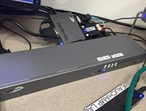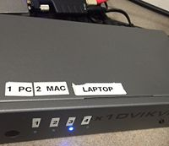

4. You should see a mirrored image of whichever computer you are using on both the ACER monitor (screen on left in pic) and the Bold screen. You are all set once it is mirrored onto the screen. (sometimes you may have to toggle the computer selector button a couple times if it is not showing up)
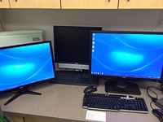

5. After Scanning Please don't forget to TURN OFF the bold screen by flipping the switch on the Bold Screen Power Strip and Log off the computer.

