Buycard Reconciliation:
The cardholder will be notified via email of an on-line statement or charges for reconciliation. All statements should be reconciled within three days of receiving this notification. Email Example:
From: Wilson, LaChandra
Sent: Friday, February 26, 2010 2:08 PM
To: Momon, Shannon; Hensley, Summer; Ortiz, Sandra; Davis, Paul
Subject: WEEKLY REMINDER - BuyCard Transactions Pending Reconciliation - Statement 03/05/2010
As a reminder, the following transactions on the March 2010 statement have posted to your departmental BuyCard accounts and are not reconciled against a purchase order:
Bill Date | Trans Date | Name | Merchant | Amount | Account | PO No.
3/5/2010 | 2/12/2010 | Buycard Holder | AMAZON MKTPLACE PM | 160.00 | ************0000
3/5/2010 | 2/15/2010 | Buycard Holder | AMAZON MKTPLACE PM | 43.84 | ************0000
- IMPORTANT: Matching the online Statement to the individual purchase order lines in PeopleSoft is necessary to disencumber the funds and subsequently close the associated purchase order. It is the Cardholders responsibility to make sure that Encumbrance Balances on PO transactions are monitored and managed correctly.
- Once an order has been received, complete a REQUISITION form found on the Financial Webpage: http://nba.uth.tmc.edu/resources/financial-office/index.htm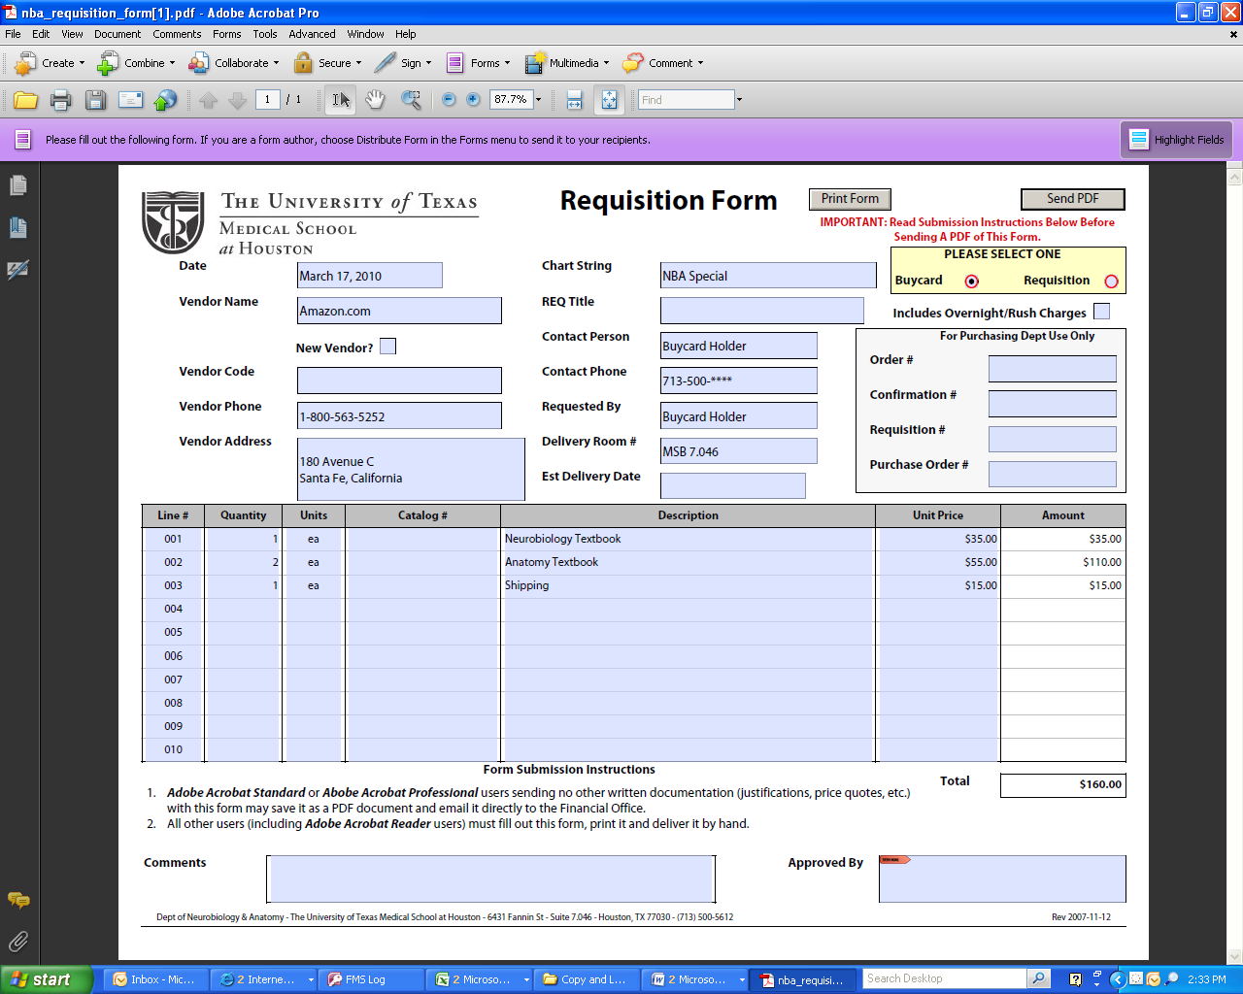
- Email or scan the required documents to MS Procurement Group Mailbox (MSB_Procurement@UTH.TMC.EDU) or deliver to the MS Procurement Mailbox located in the Dean’s Office MSB G.150. Daily pick up at 10:00AM & 2:00PM
- Attach a packing slip (or an email stating items have been received) and an Invoice
- Remember to submit your signed monthly statement once it is received.

